Answer the following questions:

1. What is a Rich Internet Application (RIA)?

Web applications that approximate the look, feel and usability of desktop applications

Two key attributes: performance and rich GIU

1. What are the two key attributes associated to RIA?

Performance and rich GIU

1. What RIA performance comes from? Explain clearly.

From Ajax, which uses client-scripting to make web applications more responsive

1. What “raw” Ajax do?

Uses Javascript to send asynchronous request to the server, then updates the page using the DOM

1. Why it is impractical to use “raw” Ajax?

Because you need to deal with cross-browser compatibility issues, making it impractical for developing large-scale applications

1. How “raw Ajax” portability issues can be managed?

Hidden by Ajax toolkits to use controls and functions that enrich web applications and simplify JS coding making it cross-broswer compatible

1. How rich GUI in RIAs isachieved?

Javascript toolkits, providing powerful ready to use controls and functions that enrich web applications

1. What data formats are used in Ajax to structure the data passed between the server and the client?

XML and JSON

1. How a traditional web application is processed? Include an image in your answer.

It was by synchronous request being processed on the server, the user first had to fill the form field and the submit, so the request can be done, then wait for the response of the server that would let you know the form was successfully submited by charging all the whole page again.

1. How an Ajax application is processed? Include an image in your answer

* A XMLHTTP request object is created
* Requests are asynchronous
* Server responds, the XML object request invokes the callback function, which uses partial page updates to display the returned data in the existing web page without reloading the entire page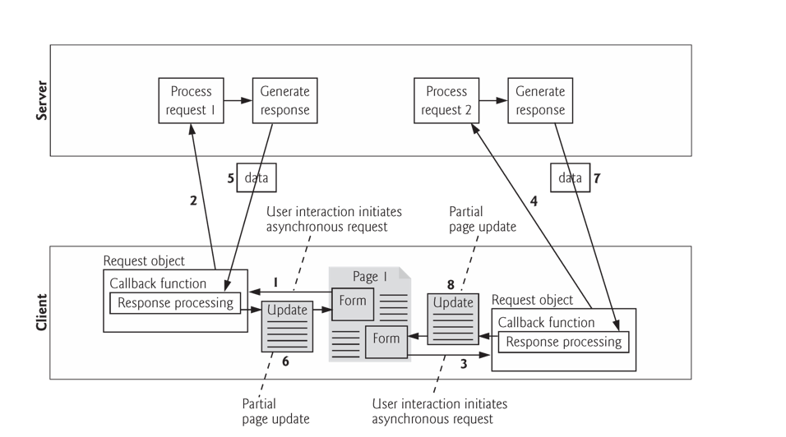

1. 12) What are the differences between classic HTML registration forms and Ajax-enabled forms?

On HTML registration forms, the data needs to be validated by the server after clicking the submit button, which makes it low performance, meanwhile with Ajax-enabled forms entries are validated individually, dynamically as the user enters the data into the fields, the entries are submitted asynchronously

1. 13) Which is the Ajax main component that manages the interaction with the server?

XMLHttpRequest Object

1. Which Company introduced it? Microsoft
2. How an asynchronous request is initiated? Include the corresponding JavaScript code (function getContent(url) in Fig. 16.5

We need to create the XMLHttp request object, then add an Event Listener with the method readyStateChange, then open the url we want to fetch with the GET method and then send the request.

It is important also, to add http status after the response, to know if it was successful or 404.

1. 15) How the Ajax callback function is registered? Indicate the JavaScript code. 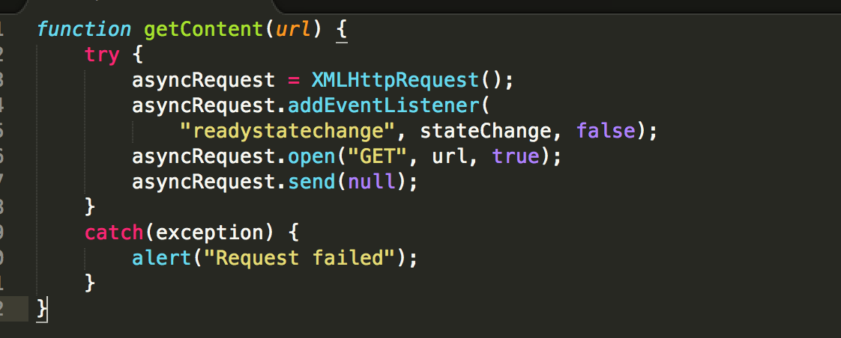
2. 16) How the XMLHttpRequest response data is managed? Incude the JavaScript code in stateChange function in Fig 16.5

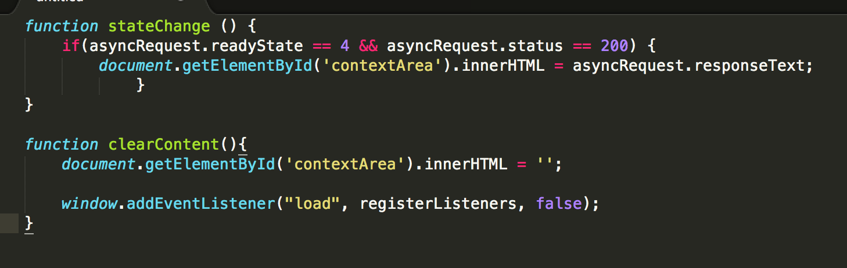

1. What the XMLHttpRequest object’s “same origin policy” (SOP) is about? What can be implemented to get content from another domain?

We can have javascript tags that loads javascript files from other websites

1. Describe the XMLHttpRequest object’s properties and events

Properties are crucial for interacting with asynchronous request

The methods initialize, configure and send asynchronous requests

1. Why XML is used to pass structured data between the server and the client? Which XMLHTTPRequest property contains the parsed XML returned by the server? Show JavaScript code in which this property is used. (Fig. 6.18)

XML consumes little bandwith and is easy to parse

XMLHttpRequest object responseXML property contains the parsed XML returned by the server

../../../Screen%20Shot%202017-09-22%20at%2009.40.58.png

1. What is JSON? It stands for Javascript Object Notation, it comes to replace the low performance from XML and replace tags
2. How a Json object is represented? Show an example

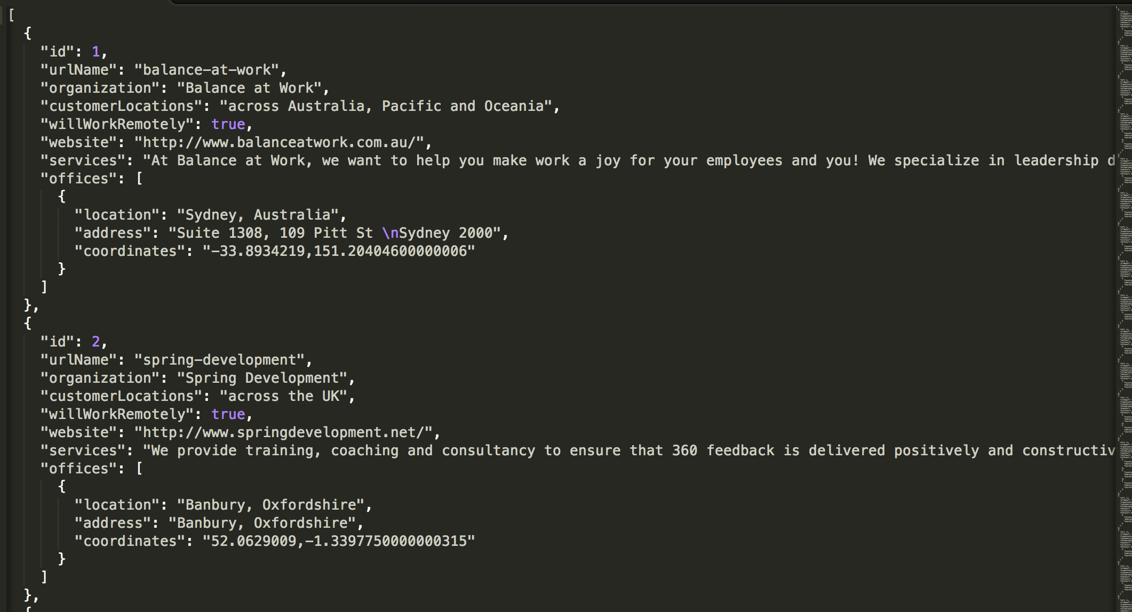

1. How an array is represented in JSON? What types can be included?

Represented in square brackets containing a command separated list of values

Each value in JSON array can be a string, number, JSON representation of an object, true, false or null

1. Why JSON is commonly used to pass structured data instead of XML?

Because its easier to create and parse than XML

Require fewer bytes

1. Try the examples in the book.